**MAR 653 Marketing Analytics**

**Final Exam**

**April 2018- June 2018 Term**

Academic Integrity: This is an individual exam and must represent your own work. Any sharing of information with other people is not allowed. Evidence of collaboration will result in a grade of zero.

**Instructions:**

1. **Your camera must be turned on at all times, not paused.**
2. **Submit a copy of your completed final to Course page:**

**Assignments and Deliverables: Final Exam: Submission, then upload the exam.**

Total possible points: 20

Part 1: Concepts – Multiple Choice (8 questions - 8 points)

Part 2: Application – Short Answers (2 questions - 12 points)

**Part1: Multiple Choice (Section Total: 8 Points, 8 questions)**

**Questions 1 – 8 are worth 1 point each.**

1. What does “k” represent in k-means cluster analysis?
2. The number of customers
3. **The number of segments**
4. The number of questions used for segmentation
5. None

**Jake Answer: B, K represents the number of segments.**

1. In the Sticks Kebob Case, a K-means clustering of the 4 questions, (I tend to plan things very carefully, I sometimes have trouble controlling my spending, I think it is important to purchase products that are made locally, I carefully consider the health benefits of what I eat) results in an elbow plot like diagram below.

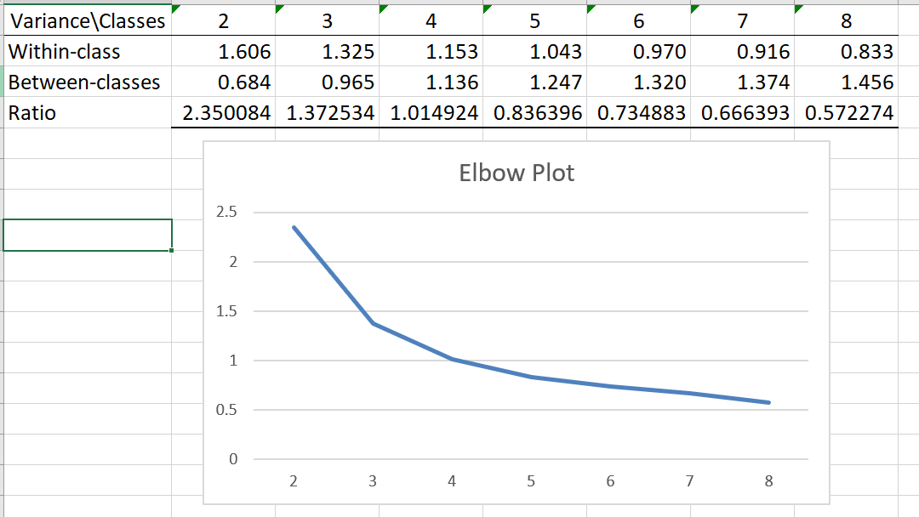

What does the elbow plot illustrate?

1. A power equation
2. An equation with upward slope
3. **Change in the ratio of within to between cluster variance as the number of clusters increase**
4. Change in the ratio of within to between clusters variance over different repetitions of the k-means clustering

**Jake Answer: C. The x axis represents the interval of K while the y axis represents the ratio of within/between cluster variance.**

1. The model used by Dunia Bank to measure CLV was essentially one that adjusted net present value of a customer, or short-term margin, using a measure of retention rate (1 – churn rate):

CLV = [M-R]* [(1 + d) / (1 + d – r)]

where M equals the current gross margins earned from a customer, R is the retention spending, d is a standard discount rate, and r is retention rate.

How does marketing affect the CLV metric above?

1. **Increases retention spending**
2. Does not affect CLV
3. Affects retention rate
4. All 3 of the above
5. Only a and c

**Marketing costs would fall under retention spending, so the ultimate value of the customer would drop as R approaches M. The actual value of R doesn’t have an impact on the value of r in the formula, so although marketing costs might lead to increased retention rates in the future, there is no numerical dependency on it.**

1. What is CLV used for?
2. To determine how much to spend to acquire a customer.
3. To determine how aggressively to spend to retain a customer
4. To value a company
5. Only a and c
6. **a, b and c**

**C is more implied, in my opinion. The value of a company could be heavily reliant on CLV as a metric, as we talked about in the live session for this week.**

1. What conditions help establish causality?
2. Change in marketing mix produces change in sales
3. Increased advertising dollars today leads to higher sales tomorrow
4. No increase in advertising results in same sales
5. **Only a and b**
6. a, b and c
7. What are good criteria for effective segmentation?
   1. Identifiable
   2. Accessible
   3. Responsive
   4. a and c only
   5. **a, b and c**

**I interpret responsive as being an indicator of the ability to use the segments and derive actionable insights via user profiles. Identifiable would be more about uniqueness of a data, as there would need to be enough differences to draw conclusions about which audience/s fall into which cluster. Accessible would tie in with ones’ access to the data, which could ultimately how we could go about targeting them for whatever marketing/advertising agenda we have.**

1. Greater the number of sales calls, greater the sales. In a system of metrics, what type of relationship does this represent?
   1. Identity
   2. **Empirical**
   3. Either Identity or Empirical depending on the business problem
   4. Neither

**This would be an example of an empirical relationship, but could also be modelled as an identity relationship depending on what’s known. You likely need to analytically model sales as a function of calls, mainly because all sales calls might not lead to direct consumer action, so you’ll have to attribute other factors into a model to adequately measure the effect on sales calls as a function of sales.**

1. Greater the number of sales calls, greater the marketing cost. In a system of metrics, what type of relationship does this represent?
   1. **Identity**
   2. Empirical
   3. Either Identity or Empirical depending on the business problem
   4. Neither

**This can be modelled directly as a function of sales calls, and the approximate cost for each, so this would be an identity metric.**

**Part2: Short Answers (Section Total: 12 Points, 2 questions)**

1. Consider the following subscription behavior information from Genie.com, a web site that provides tools for constructing a family tree (ancestor search). Subscriptions cost $9.99 per month, but you are charged for the entire year at the time of purchase. There is a one-year minimum term when you sign up for the service. Once purchased, subscriptions are set to renew automatically unless the subscriber cancels them. When a membership renews, it renews for a one-year term and again you are charged for the entire year. There are no variable costs associated with providing this service to an individual customer, but Genie does engage in customer relationship activities that they believe will increase customer retention. These customer relationship activities cost Genie about $10 per year per customer. Based on a sample of 1000 customers that joined Genie.com five years ago, near the time when the company was founded, they were able to determine how many of those customers remained subscribers in the second year, third year etc. Based on this information, Genie calculated the average annual retention rate to be 20%. Genie uses an annual discount rate of 8%.
   1. Last year, Genie spent $10,000 placing advertisements on Google. Genie management believes that these advertisements were responsible for about 300 new subscribers. Would you recommend to Genie management that they purchase more Google ads? **(2 points)**

**This equals out to an acquisition cost of $33 per user. According to my calculation via excel, her monthly CLV is valued at $11.23, far lower than her acquisition cost. If I were her, I would focus more on retaining existing customers/preventing churn, rather than trying to acquire new customers, but she does have the benefit of having the customers locked in for an entire year before they defect, so she is counting the full year customer value as soon as they register for the service. As such, it could be very lucrative for her to discount any notion of retention and just focus on acquisition.**

* 1. Suppose a newly-introduced loyalty program increases the number of customers that remained, to 30%. Does this new data change your answer to 9.a? **(2 points)**

**It increases the CLV by having a higher retention rate, but it also decreases the short term margin by adding other retention costs that detract from gross revenues. Because her retention rate is so poor, and it likely won’t change unless there is an opt out or monthly subscription structure, she would be better off pursuing leads/customer acqs than pushing retention rate.**

* 1. Do you have any hesitations or concerns about making recommendations to management based on your above estimate of customer lifetime value? **(2 points, 50 words or fewer)**

**Yes, some. The numbers above were considering a monthly lifetime value, so all revenue streams and costs were normalized as such. In reality, the customers would be locked in to contracts they prepaid into for an entire year. Taking that into account the yearly CLV would be something like $135, which far exceeds the average cost of acquisition noted above. Also, we aren’t really made aware how solid an n=1000 is in the scheme of things – Does she have 1mm customers and that wouldn’t really be representative of the population?**

1. Suppose that we want to market a new golf ball. We know from experience that there are three important features of golf balls

* Average Driving Distance
* Average Ball Life
* Price

Based on this information a conjoint analysis has been performed in which the preferences for these features were tested. The conjoint led to the following estimated attribute-level utilities.[1]

Table 1: Golf Ball Utilities

|  |  |
| --- | --- |
| **Average Driving Distance** | **Effects (or Utilities)** |
| 275 Yards | 3 |
| 250 Yards | 0 |
| 225 Yards | -3 |
| **Average Ball Life** |  |
| 54 Holes | 2 |
| 36 Holes | -1 |
| 18 Holes | -1 |
| **Price** |  |
| $1.25 | 3 |
| $1.50 | -1 |
| $1.75 | -2 |

* 1. Calculate the attribute importance scores for each attribute. Which attribute is most important in determining choice? **(3 points)**

**Calculating the importance involves taking the highest – lowest value for an attribute against the sum of the differences between all attributes. So we know our denonomiator will be (3+3)+(2+1)+(3+2) =16**

**And our importance scores are:**

**Distance: 6/14**

**Life: 3/14**

**Price: 5/14**

* 1. Suppose a company is currently considering marketing a ball with the following profile (250 Yards, 36 Holes, $1.25). How much more would the average consumer be willing-to-pay for the ball if the company increased the average distance of the ball to 275 Yards? **(3 points)**

**Because the tradeoff from the distance would represent a +3 in utility, we could reduce the price utility by 3, which nears $1.50, and the customer’s attitude about the product would not be changed.**

1. Assume that all attributes are statistically significant.